function varargout = lab10(varargin)
% LAB10 MATLAB code for lab10.fig
% LAB10, by itself, creates a new LAB10 or raises the existing
% singleton*.
%
% H = LAB10 returns the handle to a new LAB10 or the handle to
% the existing singleton*.
%
% LAB10('CALLBACK',hObject,eventData,handles,...) calls the local
% function named CALLBACK in LAB10.M with the given input arguments.
%
% LAB10('Property','Value',...) creates a new LAB10 or raises the
% existing singleton*. Starting from the left, property value pairs are
% applied to the GUI before lab10_OpeningFcn gets called. An
% unrecognized property name or invalid value makes property application
% stop. All inputs are passed to lab10_OpeningFcn via varargin.
%
% *See GUI Options on GUIDE's Tools menu. Choose "GUI allows only one
% instance to run (singleton)".
%
% See also: GUIDE, GUIDATA, GUIHANDLES
% Edit the above text to modify the response to help lab10
% Last Modified by GUIDE v2.5 05-Dec-2017 13:43:19
% Begin initialization code - DO NOT EDIT
gui_Singleton = 1;
gui_State = struct('gui_Name', mfilename, ...
'gui_Singleton', gui_Singleton, ...
'gui_OpeningFcn', @lab10_OpeningFcn, ...
'gui_OutputFcn', @lab10_OutputFcn, ...
'gui_LayoutFcn', [] , ...
'gui_Callback', []);
if nargin && ischar(varargin{1})
gui_State.gui_Callback = str2func(varargin{1});
end
if nargout
[varargout{1:nargout}] = gui_mainfcn(gui_State, varargin{:});
else
gui_mainfcn(gui_State, varargin{:});
end
% End initialization code - DO NOT EDIT
% --- Executes just before lab10 is made visible.
function lab10_OpeningFcn(hObject, eventdata, handles, varargin)
% This function has no output args, see OutputFcn.
% hObject handle to figure
% eventdata reserved - to be defined in a future version of MATLAB
% handles structure with handles and user data (see GUIDATA)
% varargin command line arguments to lab10 (see VARARGIN)
% Choose default command line output for lab10
handles.output = hObject;
% Update handles structure
guidata(hObject, handles);
% UIWAIT makes lab10 wait for user response (see UIRESUME)
% uiwait(handles.figure1);
% --- Outputs from this function are returned to the command line.
function varargout = lab10_OutputFcn(hObject, eventdata, handles)
% varargout cell array for returning output args (see VARARGOUT);
% hObject handle to figure
% eventdata reserved - to be defined in a future version of MATLAB
% handles structure with handles and user data (see GUIDATA)
% Get default command line output from handles structure
varargout{1} = handles.output;
% --- Executes on button press in pushbutton1.
function pushbutton1_Callback(hObject, eventdata, handles)
% hObject handle to pushbutton1 (see GCBO)
% eventdata reserved - to be defined in a future version of MATLAB
% handles structure with handles and user data (see GUIDATA)
cla;
clc;
get(handles.popupmenu1, 'Value')
if (get(handles.popupmenu1, 'Value') == 1)
Width = 5;
elseif(get(handles.popupmenu1, 'Value') == 2)
Width = 3;
elseif(get(handles.popupmenu1, 'Value') == 3)
Width = 1.5;
else
Width = 1;
end
step = str2double(get(get(handles.uibuttongroup1,'SelectedObject'), 'String'));
x = -5:step:5;
x1 = x(x <=0);
x2 = x(x > 0);
y1 = (1+x1)./(1+ x1.^2);
y2 = sqrt(1 + cos(x2)./(3+x2));
y = [y1 y2];
z1 = (1 + x1 + x1.^2)./(1 + x1.^2);
z2 = sqrt(1 + (2*sin(x2))./(1+x2.^2));
z = [z1 , z2];
% Width = str2double(get(handles.edit1, 'String'));
if (get(handles.listbox2, 'Value') == 1)
plot(handles.axes1,x,y,'LineWidth',Width);
else
plot(handles.axes1,x,z,'LineWidth',Width);
end
if (get(handles.checkbox1, 'Value') == get(handles.checkbox1, 'Max'))
grid on;
else
grid off;
end
% g = get(handles.checkbox1,
% --- Executes on button press in checkbox1.
function checkbox1_Callback(hObject, eventdata, handles)
% hObject handle to checkbox1 (see GCBO)
% eventdata reserved - to be defined in a future version of MATLAB
% handles structure with handles and user data (see GUIDATA)
if (get(handles.checkbox1, 'Value') == get(handles.checkbox1, 'Max'))
grid on;
else
grid off;
end
% Hint: get(hObject,'Value') returns toggle state of checkbox1
function edit1_Callback(hObject, eventdata, handles)
% hObject handle to edit1 (see GCBO)
% eventdata reserved - to be defined in a future version of MATLAB
% handles structure with handles and user data (see GUIDATA)
% Hints: get(hObject,'String') returns contents of edit1 as text
% str2double(get(hObject,'String')) returns contents of edit1 as a double
% --- Executes during object creation, after setting all properties.
function edit1_CreateFcn(hObject, eventdata, handles)
% hObject handle to edit1 (see GCBO)
% eventdata reserved - to be defined in a future version of MATLAB
% handles empty - handles not created until after all CreateFcns called
% Hint: edit controls usually have a white background on Windows.
% See ISPC and COMPUTER.
if ispc && isequal(get(hObject,'BackgroundColor'), get(0,'defaultUicontrolBackgroundColor'))
set(hObject,'BackgroundColor','white');
end
% --- Executes on selection change in popupmenu1.
function popupmenu1_Callback(hObject, eventdata, handles)
% hObject handle to popupmenu1 (see GCBO)
% eventdata reserved - to be defined in a future version of MATLAB
% handles structure with handles and user data (see GUIDATA)
% Hints: contents = cellstr(get(hObject,'String')) returns popupmenu1 contents as cell array
% contents{get(hObject,'Value')} returns selected item from popupmenu1
% --- Executes during object creation, after setting all properties.
function popupmenu1_CreateFcn(hObject, eventdata, handles)
% hObject handle to popupmenu1 (see GCBO)
% eventdata reserved - to be defined in a future version of MATLAB
% handles empty - handles not created until after all CreateFcns called
% Hint: popupmenu controls usually have a white background on Windows.
% See ISPC and COMPUTER.
if ispc && isequal(get(hObject,'BackgroundColor'), get(0,'defaultUicontrolBackgroundColor'))
set(hObject,'BackgroundColor','white');
end
% --- Executes on selection change in listbox2.
function listbox2_Callback(hObject, eventdata, handles)
% hObject handle to listbox2 (see GCBO)
% eventdata reserved - to be defined in a future version of MATLAB
% handles structure with handles and user data (see GUIDATA)
% Hints: contents = cellstr(get(hObject,'String')) returns listbox2 contents as cell array
% contents{get(hObject,'Value')} returns selected item from listbox2
% --- Executes during object creation, after setting all properties.
function listbox2_CreateFcn(hObject, eventdata, handles)
% hObject handle to listbox2 (see GCBO)
% eventdata reserved - to be defined in a future version of MATLAB
% handles empty - handles not created until after all CreateFcns called
% Hint: listbox controls usually have a white background on Windows.
% See ISPC and COMPUTER.
if ispc && isequal(get(hObject,'BackgroundColor'), get(0,'defaultUicontrolBackgroundColor'))
set(hObject,'BackgroundColor','white');
end
% --- Executes on button press in radiobutton1.
function radiobutton1_Callback(hObject, eventdata, handles)
% hObject handle to radiobutton1 (see GCBO)
% eventdata reserved - to be defined in a future version of MATLAB
% handles structure with handles and user data (see GUIDATA)
% Hint: get(hObject,'Value') returns toggle state of radiobutton1
% --- Executes on button press in radiobutton2.
function radiobutton2_Callback(hObject, eventdata, handles)
% hObject handle to radiobutton2 (see GCBO)
% eventdata reserved - to be defined in a future version of MATLAB
% handles structure with handles and user data (see GUIDATA)
% Hint: get(hObject,'Value') returns toggle state of radiobutton2
% --- Executes on button press in radiobutton3.
function radiobutton3_Callback(hObject, eventdata, handles)
% hObject handle to radiobutton3 (see GCBO)
% eventdata reserved - to be defined in a future version of MATLAB
% handles structure with handles and user data (see GUIDATA)
% Hint: get(hObject,'Value') returns toggle state of radiobutton3
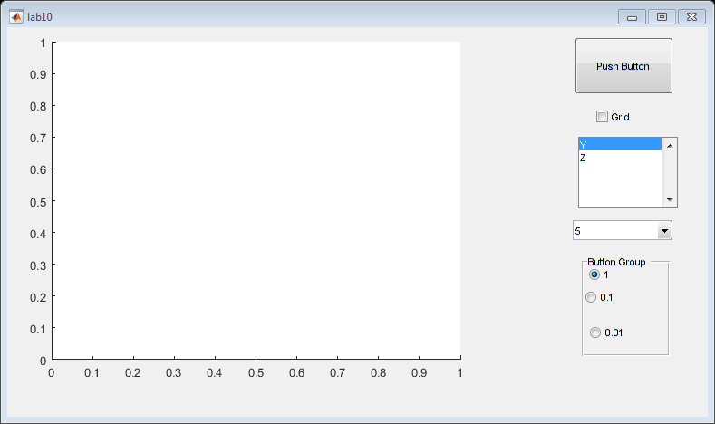
Published with MATLAB® R2017a

